INFORMATION TECHNOLOGY INSTITUTE
Analog IC Design Track

Analog Integrated Circuit Design
Lab 11
Mini Project 02
Fully-Differential Folded Cascode OTA

Table of Contents
1 Part 1: gm/ID Design Charts 4
1.1 NMOS 4
1.2 PMOS 6
2 PART 2: OTA Design 8
2.1 Specs: 8
2.2 Sizing: 9
2.2.1 Input Pair: 9
2.2.2 NMOS Current source: 9
2.2.3 Cascode NMOS: 10
2.2.4 Cascode PMOS: 10
2.2.5 Tail PMOS: 10
2.2.6 PMOS Current Source: 10
3 PART 3: Open-Loop OTA (Behavioral CMFB) 12
3.1 OP Analysis: 12
3.2 Diff small signal ccs: 13
4 PART 4: Open-Loop OTA Simulation (Actual CMFB) 16
4.1 CMFB Design: 16
4.2 OP Analysis: 17
4.3 Diff small signal ccs: 19
5 PART 5: Closed Loop Simulation (AC and STB ) 20
5.1 OP Analysis: 21
5.2 Differential closed-loop response: 22
5.3 Differential and CMFB loops stability (STB analysis): 23
6 PART 6: Closed Loop Simulation (Transient): 27
6.1 Differential and CMFB loops stability: 27
6.2 Differential and CMFB loops stability (transient analysis): 29
6.3 Output swing: 29
6.3.1 CMIR Range: 31
7 Bonus Part: 31
7.1 Bias Circuit: 31
7.1.1 AC analysis : 33

- Part 1: gm/ID Design Charts
  - NMOS
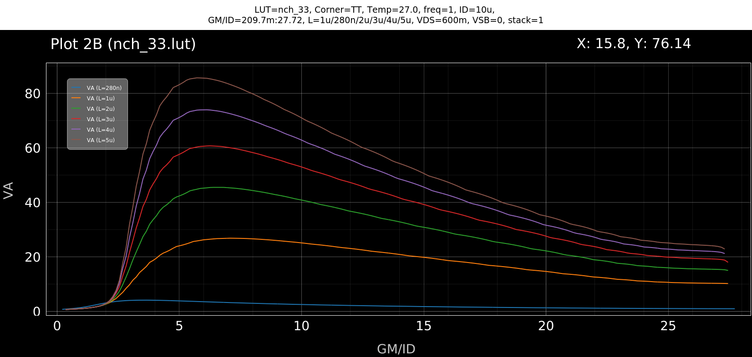
Figure 1: NMOS ($V_{A}$) vs. $g_{m}/I_{D}$.
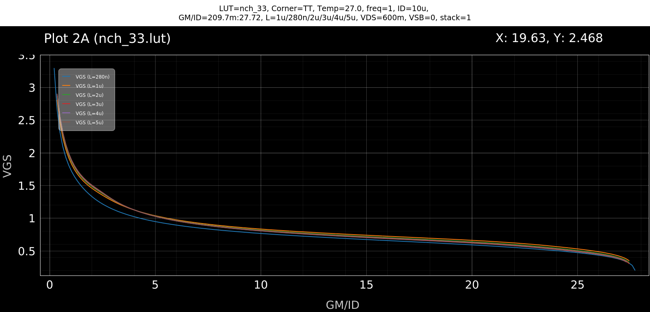
Figure 2: NMOS VGS vs. $g_{m}/I_{D}$.

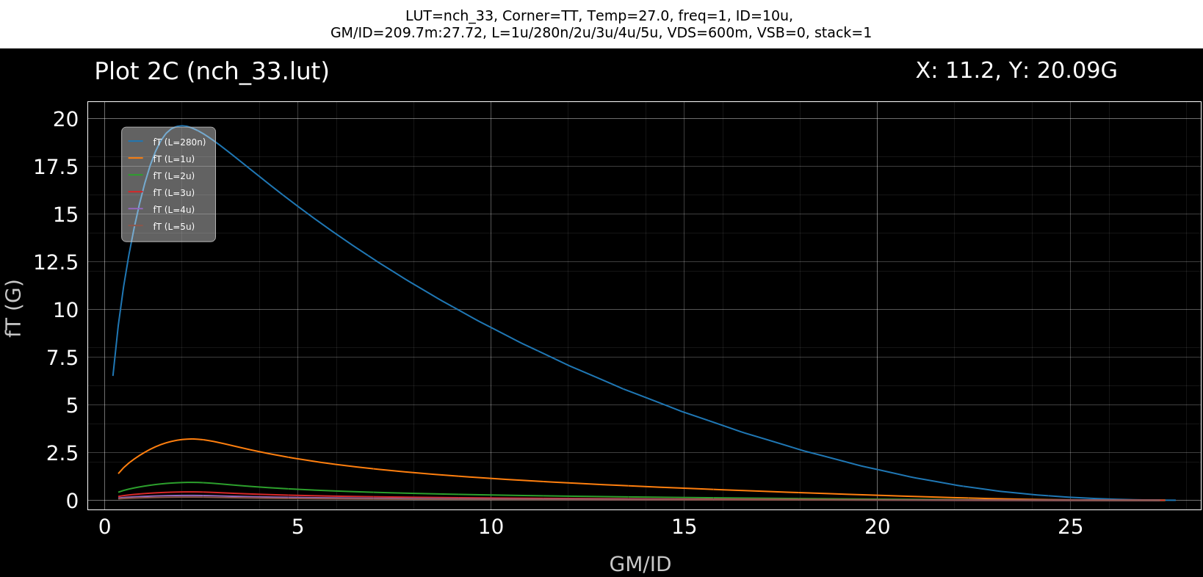
Figure 3: NMOS Transit Frequency ($f_{T}$) vs. $g_{m}/I_{D}$
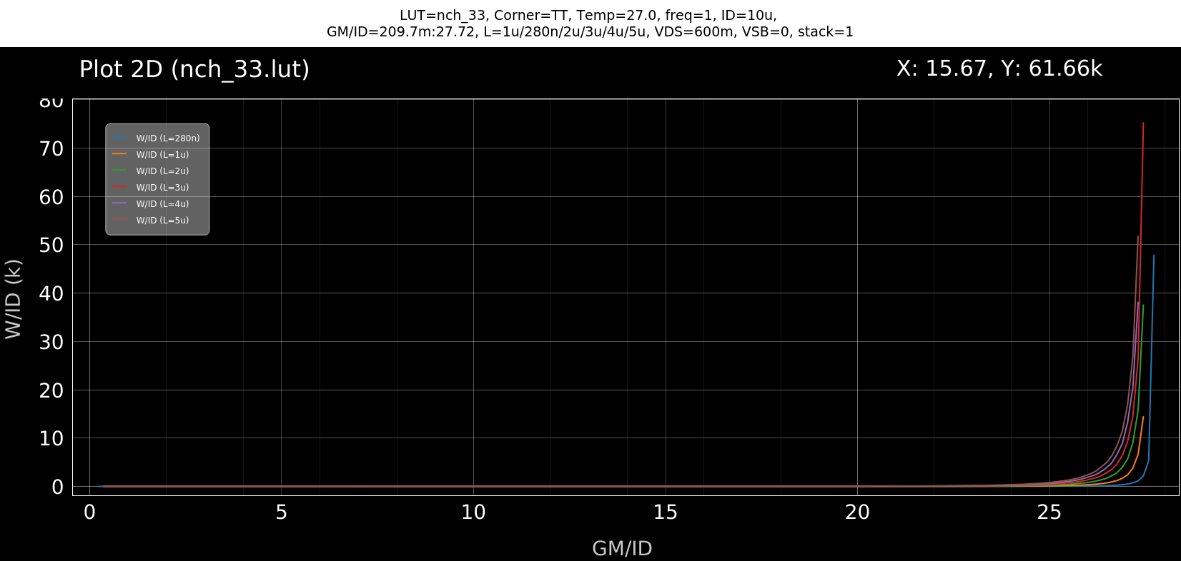
Figure 4: NMOS $W/I_{D}$ vs. $g_{m}/I_{D}$.

  - PMOS
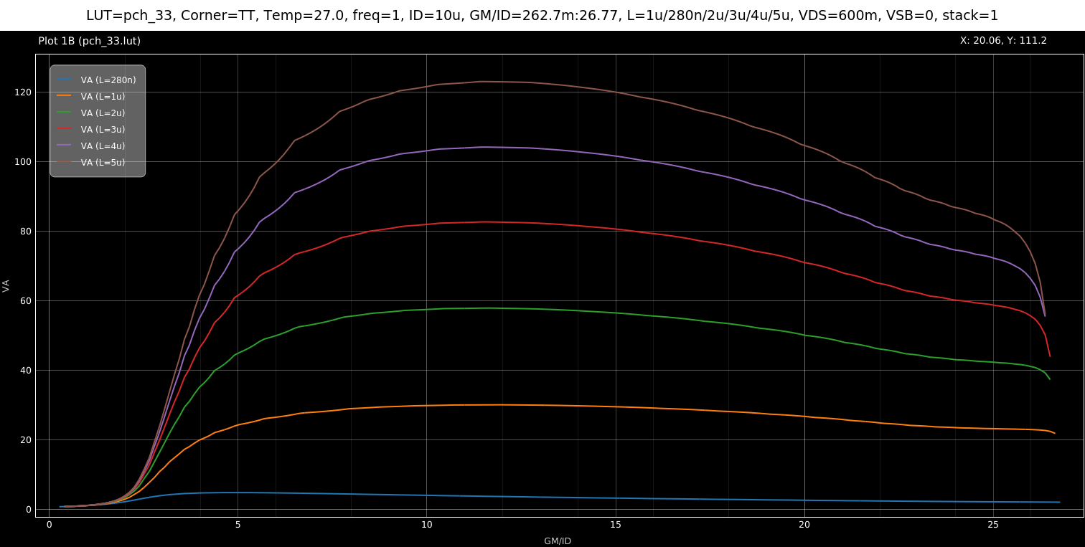
Figure 5: PMOS ($V_{A}$) vs. $g_{m}/I_{D}$.
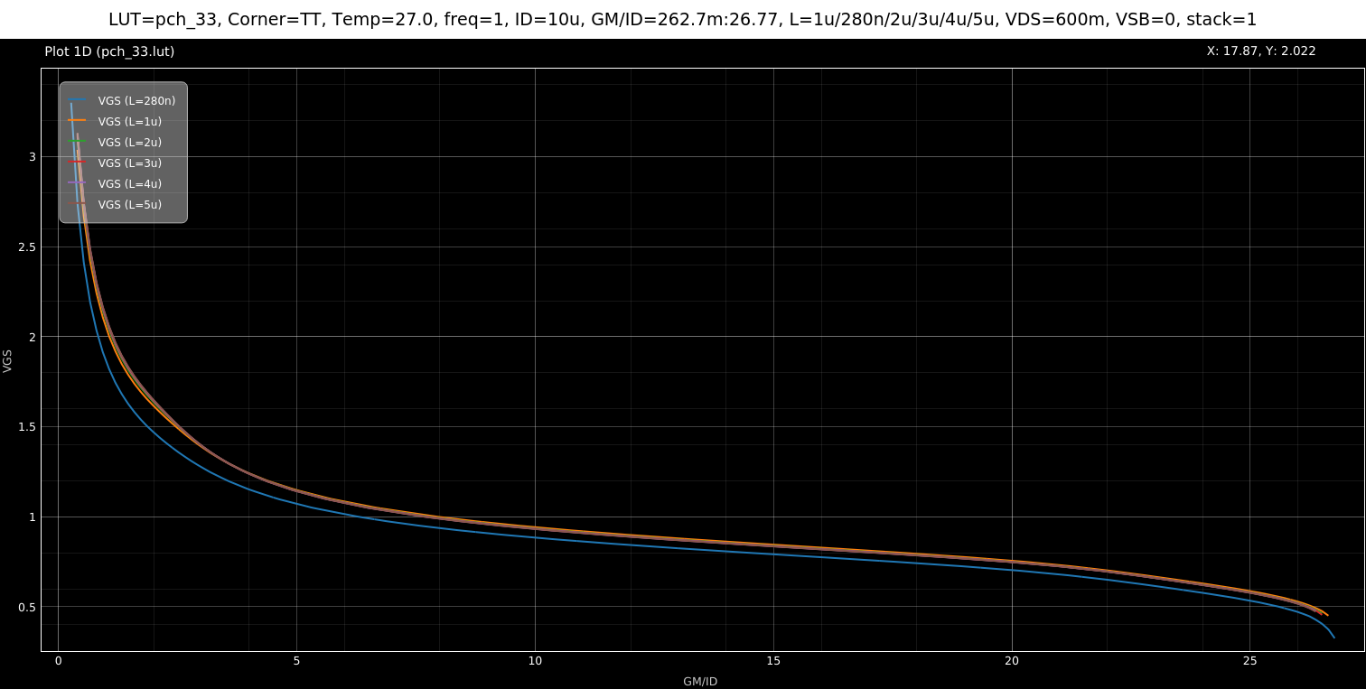
Figure 6: PMOS VGS vs. $g_{m}/I_{D}$.

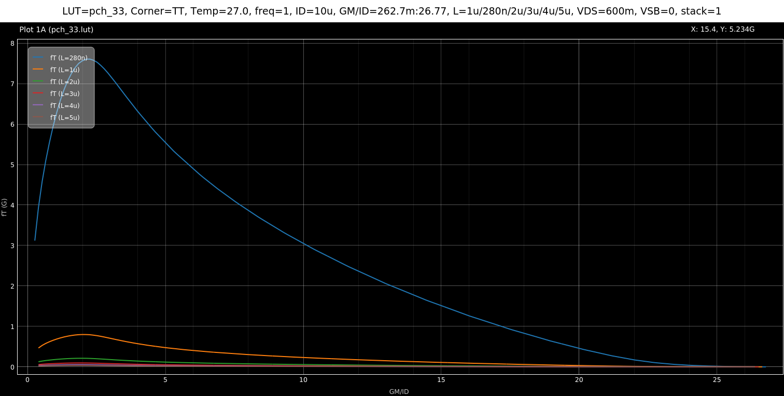
Figure 7: PMOS Transit Frequency ($f_{T}$) vs. $g_{m}/I_{D}$
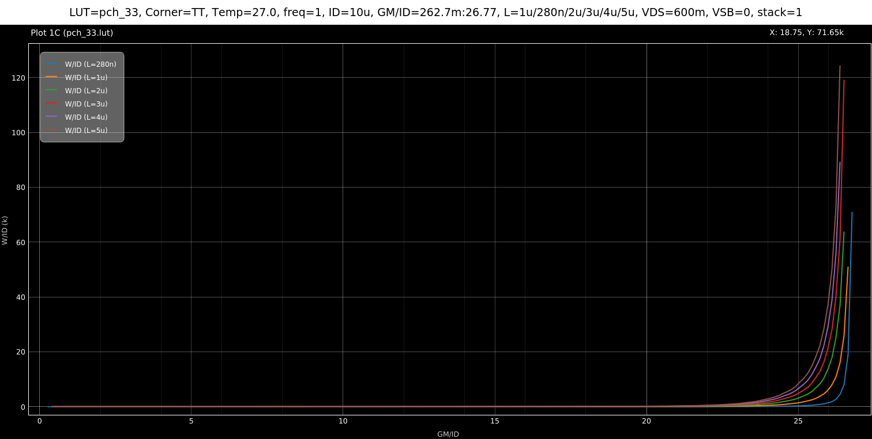
Figure 8: PMOS $W/I_{D}$ vs. $g_{m}/I_{D}$.

- PART 2: OTA Design
  - Specs:
Parameter | Specification (GF180MCU)
Supply Voltage ($V_{DD}$) | 2.5 V
Closed Loop Gain ($A_{CL}$) | 2 V/V
Phase Margin (at target $A_{CL}$) | $$≥{70}^{∘}$$
CM Input Range - Low | $≤0$ V
CM Input Range - High | $≥1$ V
Differential Output Swing | 1.2 V peak-to-peak
Load Capacitance ($C_{L}$) | 500 fF
DC Loop Gain | 60 dB
Closed-Loop Settling Time (1% error) | 100 ns

First, we will choose pmos input pair since the CM input low is 0V.
Taking the loading effect into consideration:
$$β=\frac{C_{F}}{C_{F}+C_{IN}}=\frac{1p}{1p+2p}=\frac{1}{3}$$
$$LG=60dB→1000=A_{OL}*β→A_{OL}=3000$$
$$A_{OL}=\frac{C_{IN}}{C_{F}+C_{IN}}*Ao=\frac{2p}{1p+2p}*Ao=\frac{2}{3}*Ao$$
$$BW_{OL}= BW_{OTA}$$
Gain-Bandwidth Product (GBW) Relationships
$$\left(\frac{C_{in}}{C_{in}+C_{f}}\right)A_{o}⋅BW_{OTA}=A_{cl}⋅BW_{cl}$$
$$GBW_{OTA}=3⋅BW_{cl}$$
$$GBW_{OTA}=\frac{g_{m}}{2πC_{out}}$$
$$C_{out}=C_{L}+\left(C_{f}∥C_{in}\right)=1.167 pF$$

Using the 1% error settling time:
$$e^{-\frac{T}{τ}}*100=1→τ=21.7ns$$
$$BW_{CL}=\frac{1}{2πτ}=7.33MHz$$
$$GBW_{CL}=A_{CL}*BW_{CL}=\frac{BW_{CL}}{Beta}= 22MHz=\frac{gm_{in}}{2π\left(C_{out},tot\right)}→gm_{in}≈161μS$$
We will take $gm_{in}≈165μS$
Output Resistance is $R_{out}=\left(r_{o3}g_{m3}\left(r_{o2}∥r_{o3}\right)\right)∥\left(r_{o4}g_{m4}r_{o5}\right)$
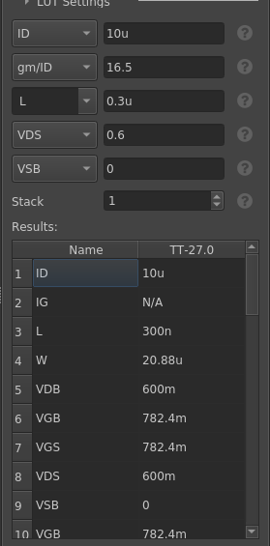
  - Sizing:
    - Input Pair:
Let L = 300nm we will take min L to reduce Cgg.
$$gm_{in}≈165μS$$
Assume $g_{m}/I_{D}=16.5$
So we will get that the current is $I_{D}=10μA$
$$W=20.88 μ\text{m}$$

Figure 9: input pair
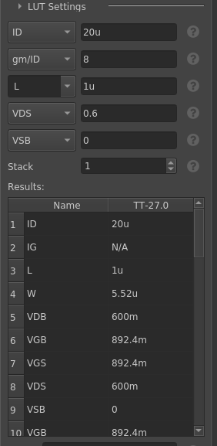
    - NMOS Current source:
choosing large L for bigger ro to reduce noise and mismatch.
Figure 10: NMOS CS
$$L=1μm$$
And biasing in SI for lower gm and lower noise
$$\frac{gm}{I_{D}}=8$$
we get
$$W=5.52 μ\text{m}$$

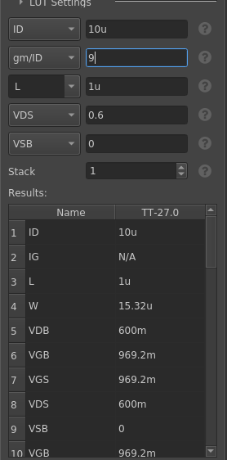
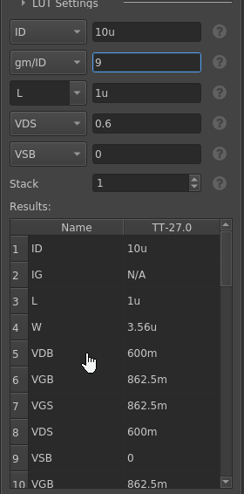
    - Cascode NMOS:
Choosing Large L= 1$μm$ and
Figure 11: Cascode Nmos
$$\frac{gm}{ID}=9$$
We get W = 3.56 u

    - Cascode PMOS:
Choosing Large L= 1$μm$ and
$$\frac{gm}{ID}=9$$
We get W = 15.3 u
Figure 12: Cascode Pmos

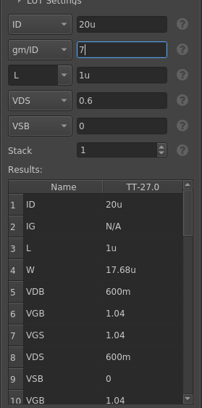
    - Tail PMOS:
Choosing Large L= 1$μm$ for lower mismatch and
Figure 13: Tail PMOS
$$\frac{gm}{ID}=7$$
To lower gm for lower noise
We get W = 17.68u

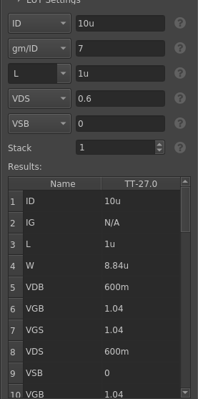
    - PMOS Current Source:
Figure 14: PMOS CS
Same as the tail
We get W = 8.84 u

Bias Voltages:
$$V_{CASCN}=V_{GScascN}+V_{MN}^{*}=1.11V$$
$$V_{CASCP}=V_{DD}-V_{GScascP}-V_{MP}^{*}=1.24V$$
Since we didn’t take the body effect into consideration so we must Choose slighter higher and lower values to ensure transistor operate in saturation:
$$V_{CASCN}=1.2V$$
$$V_{CASCP}=1..15V$$

Table 1: Final Sizing
Transistor | Function | Type | ID​ (μA) | gm​/ID​ | L (μm) | W (μm)
M1 | Input Pair | PMOS | 10 | 16.5 | 0.3 | 20.88
M2 | Sink Mirror | NMOS | 20 | 8.0 | 1.0 | 5.52
M3 | Cascode | NMOS | 10 | 9.0 | 1.0 | 3.56
M4 | Cascode | PMOS | 10 | 9.0 | 1.0 | 15.32
M5 | Current Source | PMOS | 10 | 7.0 | 1.0 | 8.84
M6 | Tail Source | PMOS | 20 | 7.0 | 1.0 | 17.68

- PART 3: Open-Loop OTA (Behavioral CMFB)
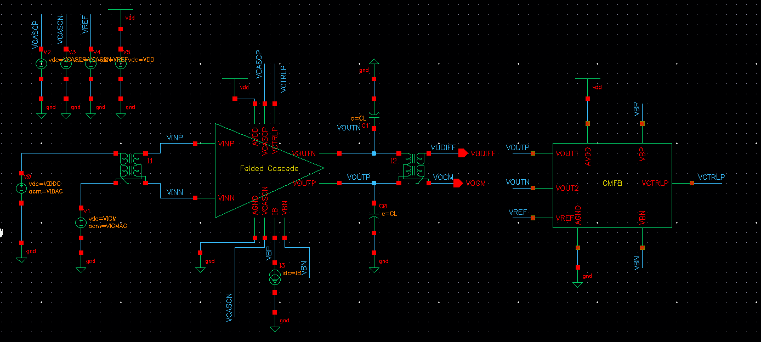
Figure 12: Open Loop Schematic
  - OP Analysis:
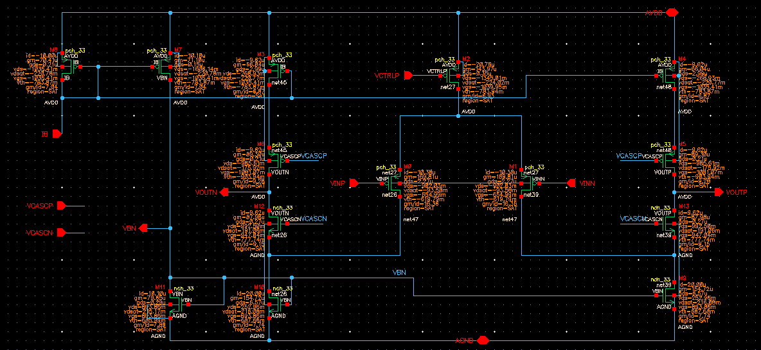
Figure 13: OP parameters before
Transistor(s) | Type | Function | ID​ (µA) | VGS​ | VDS​ | VDSAT​ | VTH​ | gm​ | gds​ | Region
M0, M1 | PMOS | Input Pair | -10.42 | -655.31 | -981.58 | -93.59 | -620.78 | 170.27 | 2.29 | SAT
M2 | PMOS | Tail Source | -20.84 | -1090.47 | -1343.89 | -224.40 | -791.94 | 144.23 | 0.35 | SAT
M3, M4 | PMOS | Top Sources | -9.70 | -1035.41 | -303.95 | -220.77 | -753.87 | 67.40 | 1.06 | SAT
M5, M6 | PMOS | Cascodes | -9.70 | -1046.05 | -851.12 | -161.47 | -913.14 | 109.96 | 0.55 | SAT
M9, M10 | NMOS | Bottom Sinks | 20.11 | 893.86 | 274.73 | 216.08 | 687.69 | 157.18 | 4.28 | SAT
M12, M13 | NMOS | Cascodes | 9.70 | 925.27 | 970.28 | 169.18 | 728.73 | 100.92 | 4.72 | SAT
M8 | PMOS | Bias Diode | -10.00 | -1035.41 | -1035.41 | -220.78 | -753.87 | 70.41 | 0.21 | SAT
M7 | PMOS | Bias Mirror | -10.10 | -1035.41 | -1006.14 | -220.78 | -753.87 | 71.10 | 0.15 | SAT
M11 | NMOS | Bias Diode | 10.10 | 893.86 | 893.86 | 215.17 | 685.09 | 79.65 | 0.29 | SAT

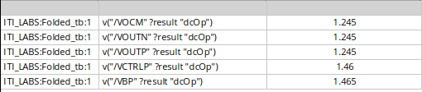

What is the CM level at the OTA output?
($V_{OCM}$) is 1.245V. which is the reference voltage ($V_{REF}$) to approximately half of the 2.5V supply.
What are the differential input and output voltages of the error amplifier? What is the relation
between them?
The inputs of CMFB are common-mode voltage ($V_{CM}$) and the target reference ($V_{REF}$). $Vdiff = 5mV$. Its output is $V_{CTRLP}$. Because the ideal error amplifier is assigned a gain of 1, the relationship is defined by:
$$V_{CTRLP}=V_{BP}+1⋅\left(V_{CM}-V_{REF}\right)$$
The simulation confirms this: with $V_{OCM}=1.245\text{V}$, the generated $V_{CTRLP}$ is at 1.46V, which is almost perfectly aligned with the bias voltage $V_{BP}$ of 1.465V.
  - Diff small signal ccs:
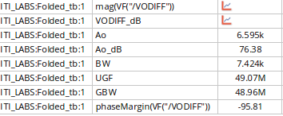
Figure 14: Ac parameters before resizing
As we see the open loop gain is very high more than required (3000), to reduce it we need to reduce Rout.
For the cascode devices we will reduce gm and ro so we will reduce the W and L
For Cascode NMOS:
Reduce W from 3.56u to 2.54u and L from 1u to 0.5u.
For Cascode PMOS:
Reduce W from 15.3u to 10u and L from 1u to 0.5u.
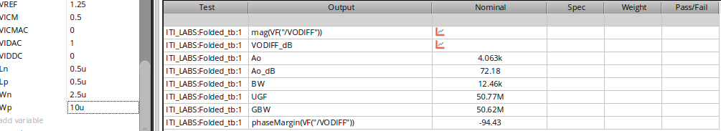
Figure 15: AC parameters after resizing
The PM is = 180 – 94 = 85
Also I checked the OP parameters again
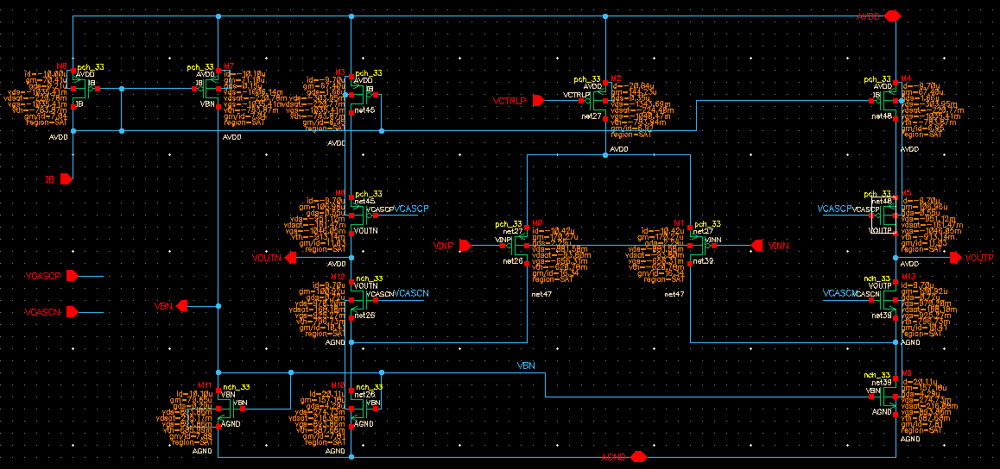
Figure 16: OP after resizing
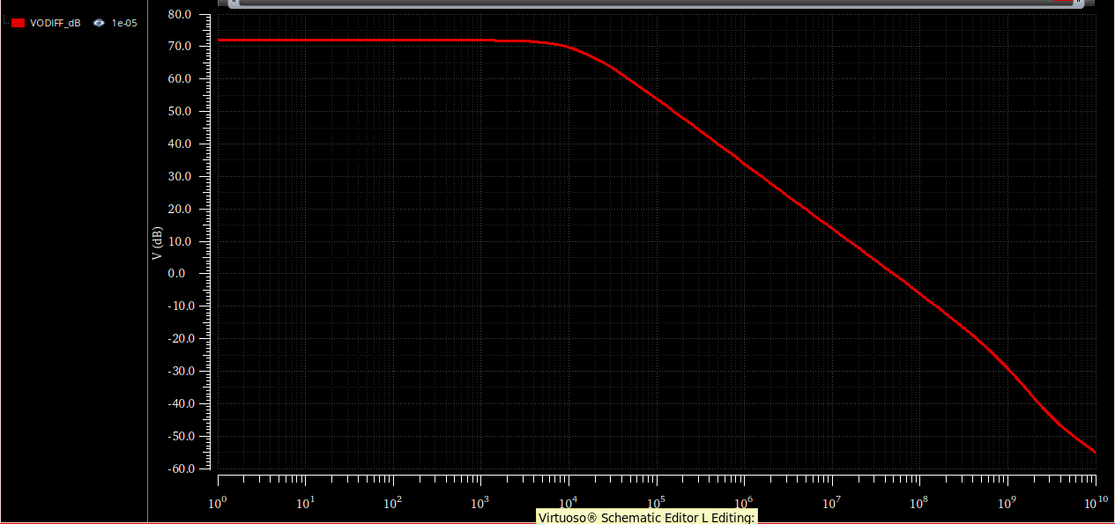
Figure 17: Differential open-loop magnitude response (dB) vs. frequency.
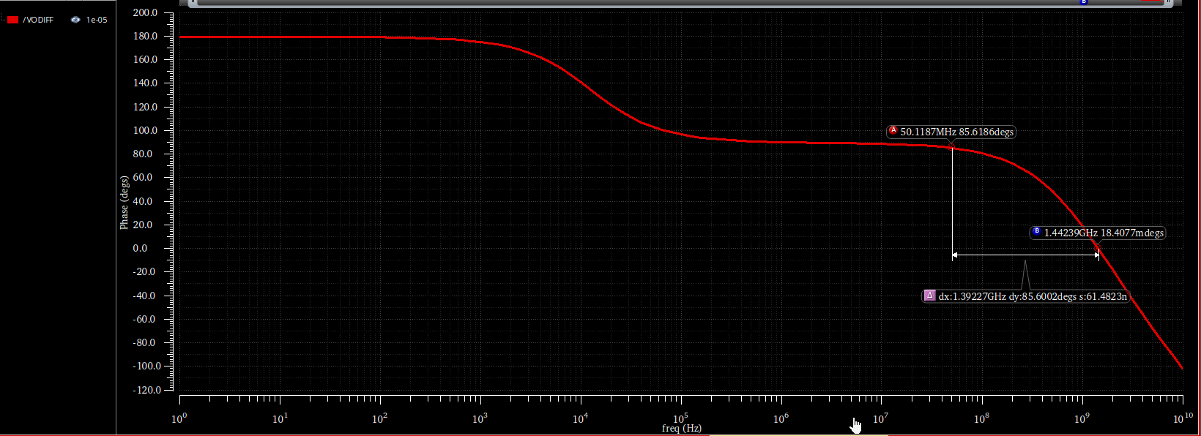
Figure 18: Differential open-loop phase response vs. frequency.
$$PM = 85°$$
Hand Analysis:
$$R_{OUT}=\left[gm_{cascn}ro_{cascn}\left(r_{mn}//ro_{inp}\right)\right]//gm_{cascp}ro_{cascp}ro_{mp}≈19MΩ$$
$$A_{OL}=GmR_{OUT}=170μ*19M=3.23K$$
$$BW_{OL}=\frac{1}{2πR_{OUT}C_{OUT}}≈16.75KHz$$
$$GBW_{OL}=UGF=A_{OL}*BW_{OL}=54MHz$$
 | Simulation | Hand Analysis
Aol | 72.18 dB (4063 V/V) | 3230
BW | 12.46 kHz | 16.75KHz
GBW | 50.62 MHz | 454MHz
UGF | 50.77 MHz | 54MHz

- PART 4: Open-Loop OTA Simulation (Actual CMFB)
  - CMFB Design:
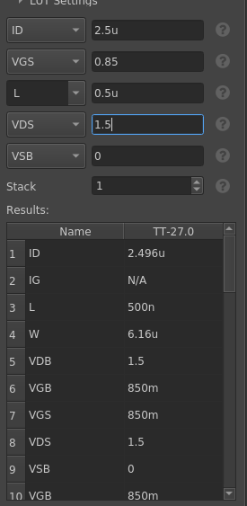
I designed the CMFB circuit to have 25% of the current budget of the OTA which is 10uA so every branch will have current = 2.5 uA.
First lets estimate the sensing resistance , in worst case the $∆Vout=1.2$ if I choose the R = 50k as in the lab which makes Ix = 1.2/100k = 12u we must have a current in the common drain larger than 12 u but I designed to make it 2.5u so we will increase the R to be 250k instead of 50k that makes Ix = 2.4uA and that’s fine.
$$R ≥ \frac{0.6}{2.5u}$$
$$R≥240k$$
I will take R = 250k
The Pmos current sources will have a width W = 2.21u and L = 1u which is half width of the pmos CS of main OTA.
For the tail NMOS CS will have a width equals the quarter of the NMOS CS of the OTA W=1.38u
For the NMOS inputs of the differential pair we will sweep over W to make the gm of the diff pair equals the gm of the active loads to have a gain of 1.
We found the equal gm at W =0.6u.
Also since Vout had a positive shift because of the Common drain , so we will shift the Vref by the same shift so we will use same sizing.
Calculating new Output Swing:
$$minimum Output Swing=V_{CASCN}^{*}+V_{MN}^{*}≈0.5$$
$$maximum Output Swing=V_{DD}-V_{GSP}-V_{P}^{*}=1.5$$

$$Middle of Output Swing={V_{REF}}_{new}≈1V$$
  - OP Analysis:
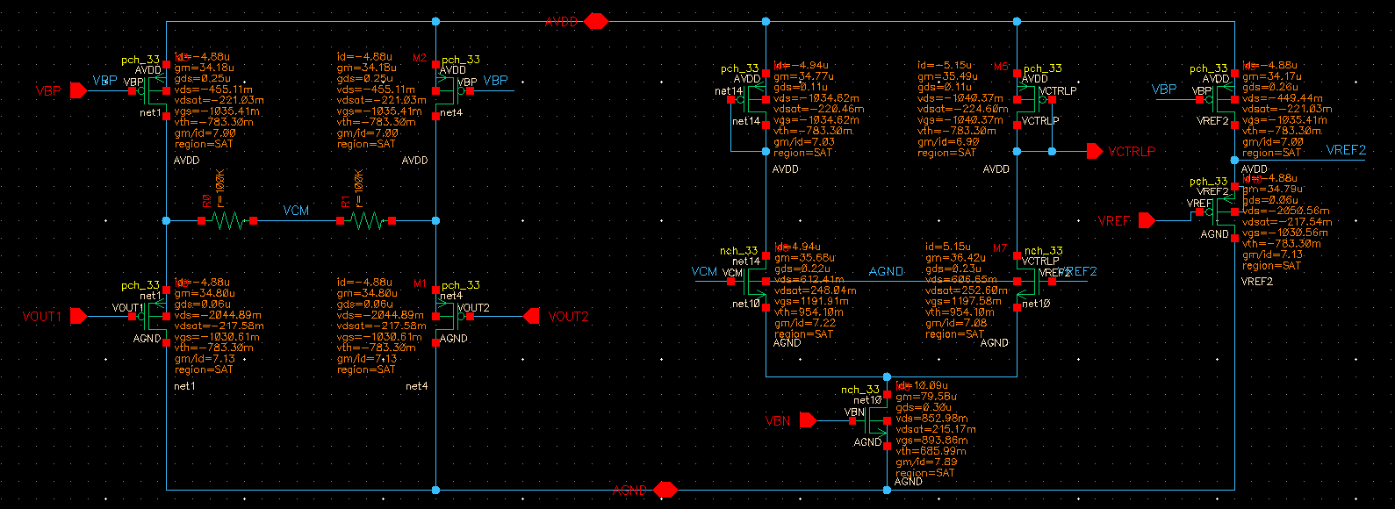
Figure 19: DC operating point of the actual CMFB

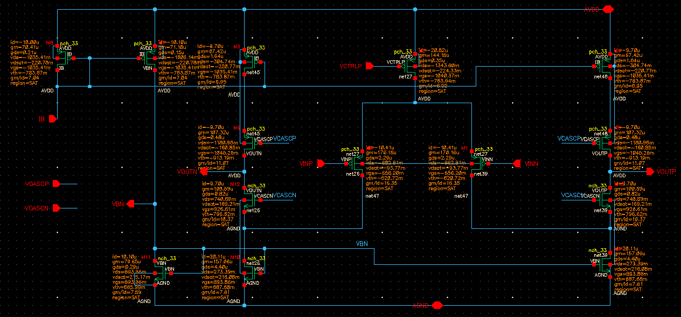
Figure 20: DC operating point of the main folded-cascode OTA
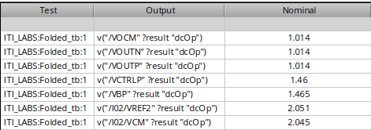
Figure 21: VOCM where VREF2 is VREF after shifting
Table 2: Main OTA & Biasing DC Operating Point
Transistor(s) | Function | ID​ (µA) | VGS​ (mV) | VDS​ (mV) | VDSAT​ (mV) | VTH​ (mV) | gm​ (µS) | gds​ (µS) | Region
M0, M1 | Input Pair | 10.41 | 656.20 | 882.81 | 93.77 | 620.72 | 170.18 | 2.29 | SAT
M2 | Tail Source | 20.82 | 1040.37 | 1343.80 | 224.33 | 783.94 | 144.18 | 0.35 | SAT
M3, M4 | Top Sources | 9.70 | 1035.41 | 304.74 | 220.77 | 753.87 | 67.42 | 1.64 | SAT
M5, M6 | Cascodes | 9.70 | 1045.26 | 1180.98 | 160.85 | 913.18 | 107.32 | 0.48 | SAT
M9, M10 | Bottom Sinks | 20.11 | 893.86 | 273.39 | 216.06 | 687.68 | 157.06 | 4.40 | SAT
M12, M13 | Cascodes | 9.70 | 926.61 | 740.89 | 169.21 | 798.62 | 100.59 | 0.82 | SAT
M8 | Bias Diode | 10.00 | 1035.41 | 1035.41 | -220.78 | 753.87 | 70.41 | 0.21 | SAT
M7 | Bias Mirror | 10.10 | 1035.41 | 1006.14 | 220.78 | 753.87 | 71.10 | 0.15 | SAT
M11 | Bias Diode | 10.10 | 893.86 | 893.86 | 215.17 | 685.09 | 79.65 | 0.29 | SAT

Table 3: CMFB Circuit DC Operating Point
Transistor(s) | Function | ID​ (µA) | VGS​ (mV) | VDS​ (mV) | VDSAT​ (mV) | VTH​ (mV) | gm​ (µS) | gds​ (µS) | Region
CD Buffers | Level Shifters | 4.88 | 1030.61 | 2044.89 | 217.58 | 783.30 | 34.80 | 0.06 | SAT
CD Bias | Buffer Sources | 4.88 | 1035.41 | 455.11 | 221.03 | 783.30 | 34.18 | 0.25 | SAT
Err Amp In | Diff Pair | 5.04 | 1194.75 | 609.53 | 250.32 | 954.10 | 36.05 | 0.22 | SAT
Err Amp Load | Diode Loads | 5.00 | 1037.49 | 1037.49 | 222.53 | 783.30 | 35.13 | 0.11 | SAT
Err Amp Tail | Tail Source | 10.09 | 893.86 | 852.98 | 215.17 | 685.99 | 79.58 | 0.30 | SAT
VREF Buffer | Level Shifter | 4.88 | 1030.56 | 2050.56 | 217.54 | 783.30 | 34.79 | 0.06 | SAT

What is the CM level at the OTA output? Why?
VoCM = 1.014 which is almost equal to Vref=1, the CMFB senses the average and compares it to Vref and return to the tail CS forcing Vocm to follow Vref.

What are the differential input and output voltages of the error amplifier? What is the relation
between them?
$$VDIFF_{IN}=2.051-2.045= 6mV$$
$$VDIFF_{OUT}=1.465-1.46=5 mV$$
$$\frac{VDIFF_{OUT}}{VDIFF_{IN}}=0.833$$
  - Diff small signal ccs:
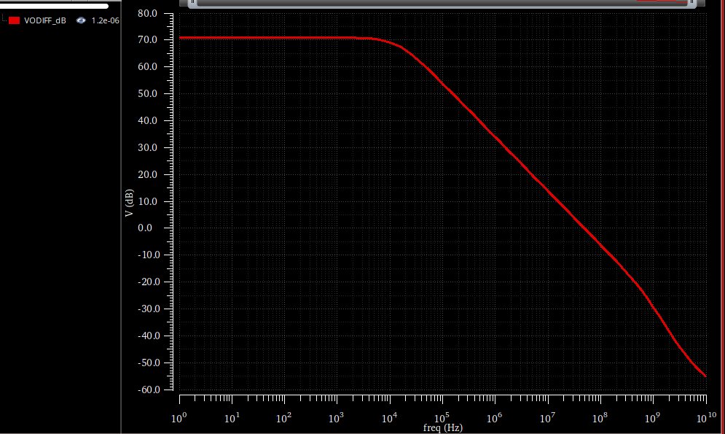
Figure 22: Differential open-loop magnitude response (dB) with actual CMFB loading
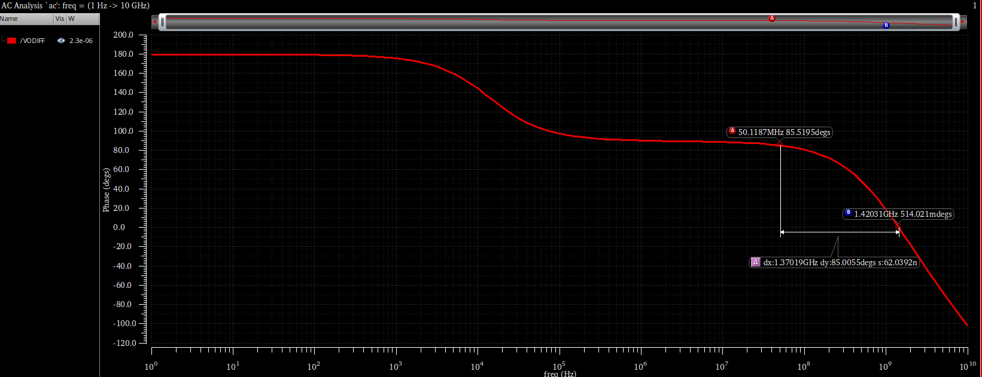
Figure 23: Differential open-loop phase response with actual CMFB loading

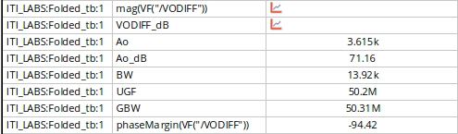
Figure 24: AC Values
$$PM = 180-94=85°$$
Parameter | Behavioral CMFB | Actual CMFB
DC Gain ($A_{0}$) | 72.18 dB | 71.16 dB (3.615k V/V)
-3dB Bandwidth (BW) | 12.46 kHz | 13.92 kHz
Unity Gain Freq. (UGF) | 50.77 MHz | 50.20 MHz
Gain-Bandwidth (GBW) | 50.62 MHz | 50.31 MHz
Phase Margin (PM) | 85.6° | 85.5°

- PART 5: Closed Loop Simulation (AC and STB )
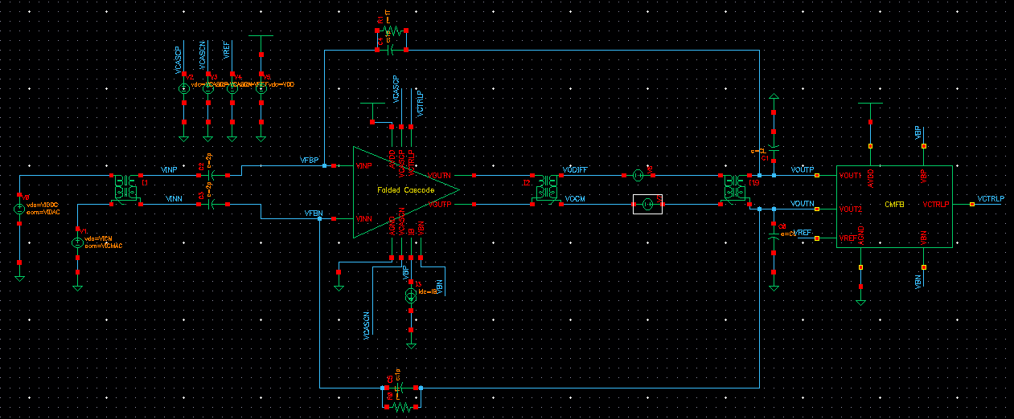
Figure 25: Closed Loop Schematic

  - OP Analysis:
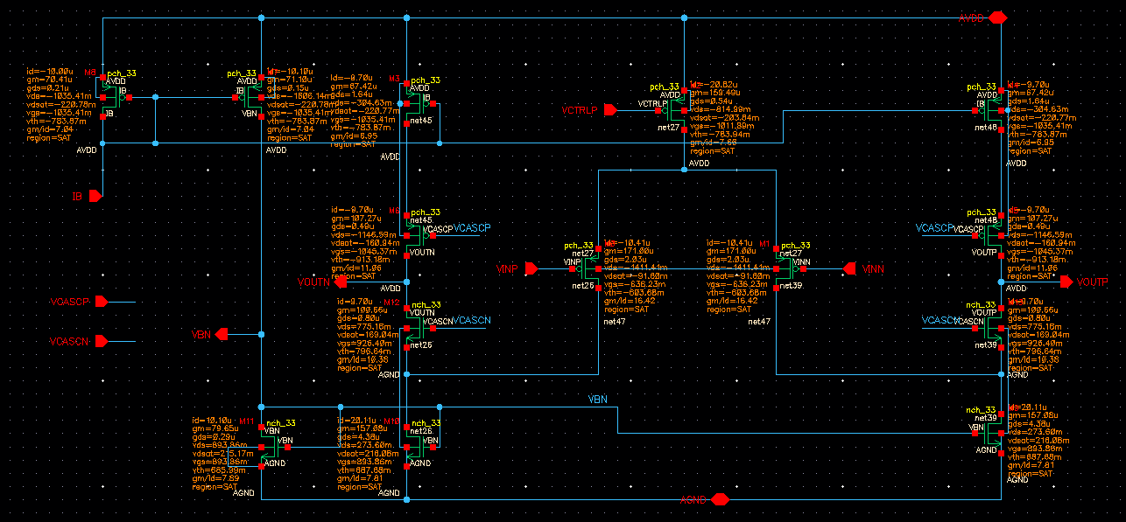
Figure 26: Folded OP
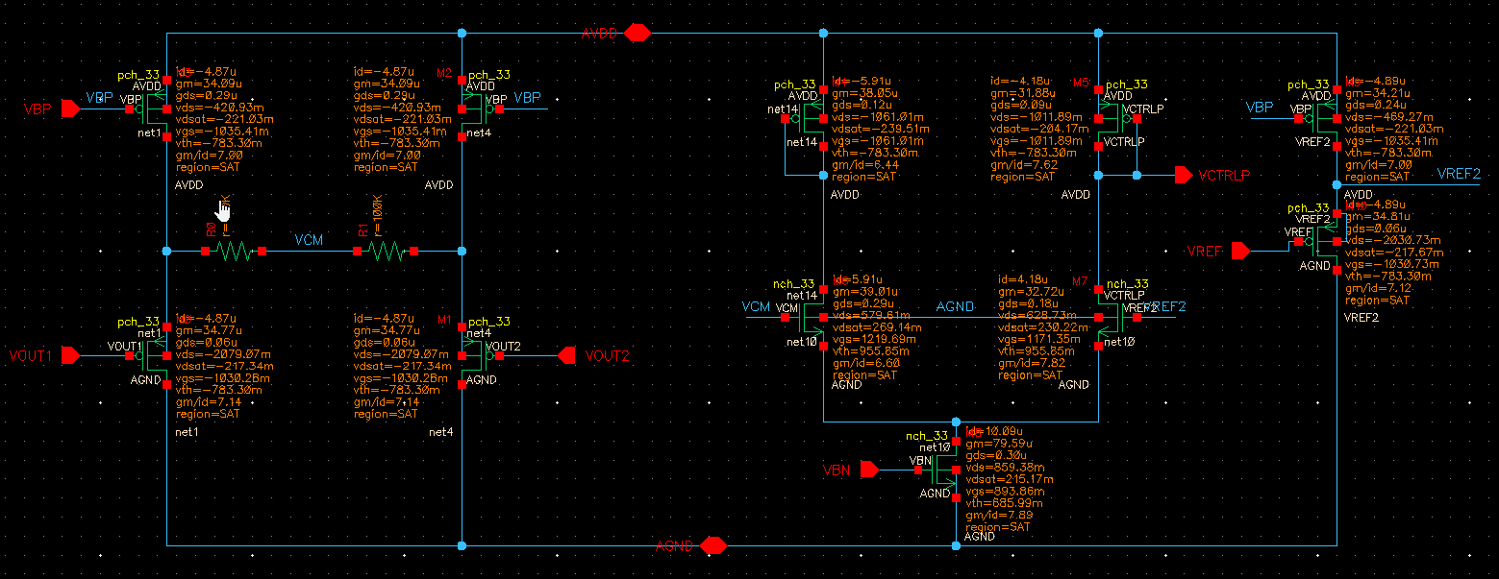
Figure 27: CMFB OP
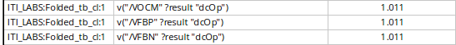
Figure 28: OP

What is the CM level at the OTA output? Why?
It equals to 1.011 almost 1 as Vref.
What is the CM level at the OTA input? Why?
Also It equals to 1.011 almost 1 as Vref. Follows the output by the feedback.
  - Differential closed-loop response:
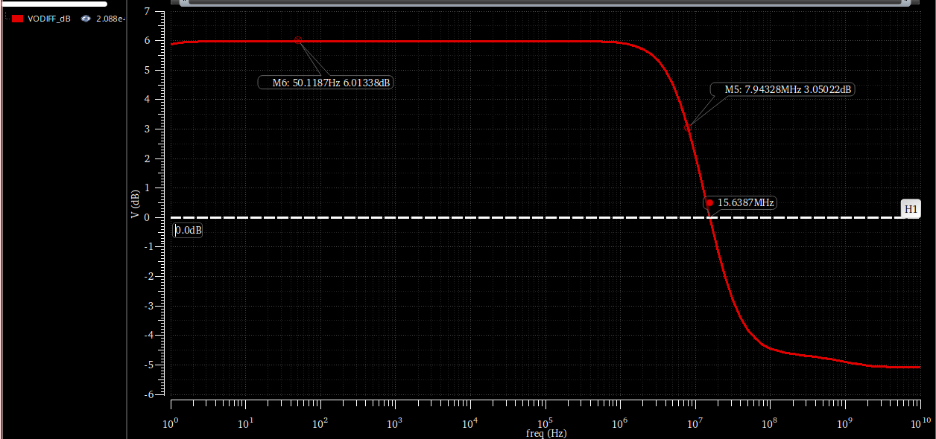
Figure 29: Closed-loop differential magnitude response (dB).
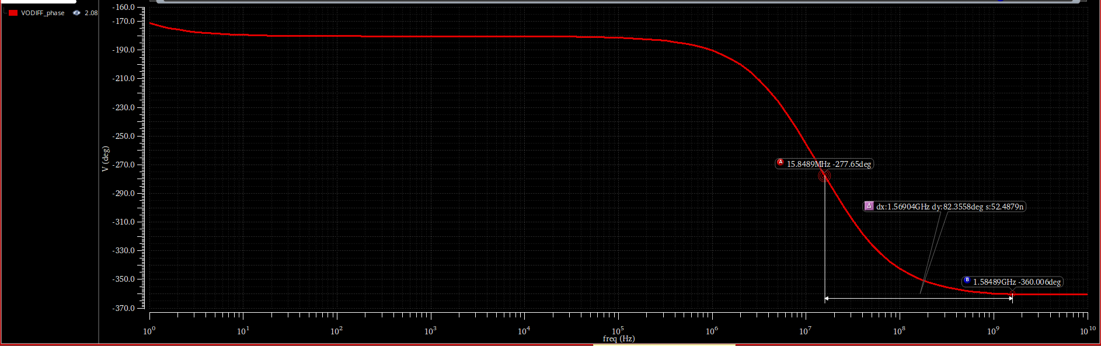
Figure 30: Closed-loop differential phase response
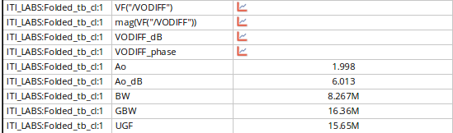
Figure 31:AC
$$GBW_{CL}=GBW_{Loaded}* \frac{2}{3}$$
$$GBW_{loaded}=23 MHz=\frac{g_{m}}{2πC_{tot}} from part 4$$
SO
$$GBW_{CL}=15.33 MHz$$
So our GBW meets the specs
$$\left(\frac{C_{in}}{C_{in}+C_{f}}\right)A_{o}⋅BW_{OTA}=A_{cl}⋅BW_{cl}$$
$$BW_{cl}=\frac{GBW_{loaded}}{3}=7.67 MHz$$

  - Differential and CMFB loops stability (STB analysis):
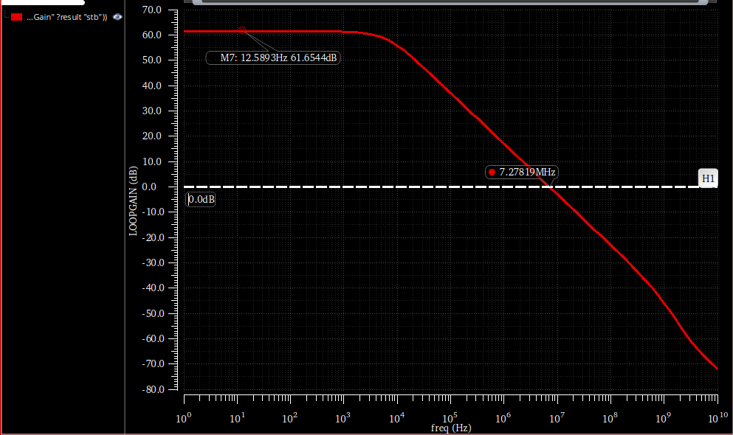
Figure 32: Differential Loop Gain magnitude (dB).
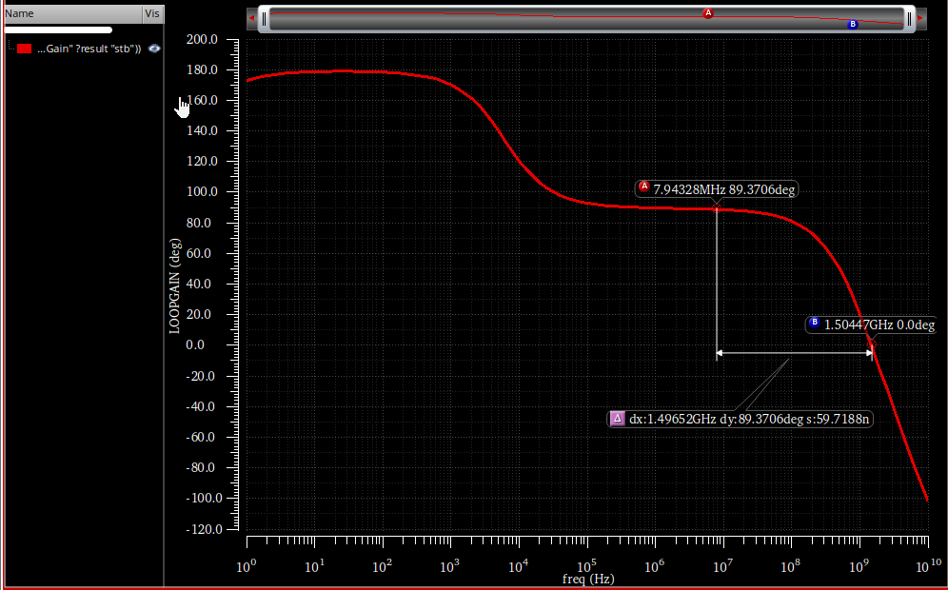
Figure 33: Differential Loop Gain phase
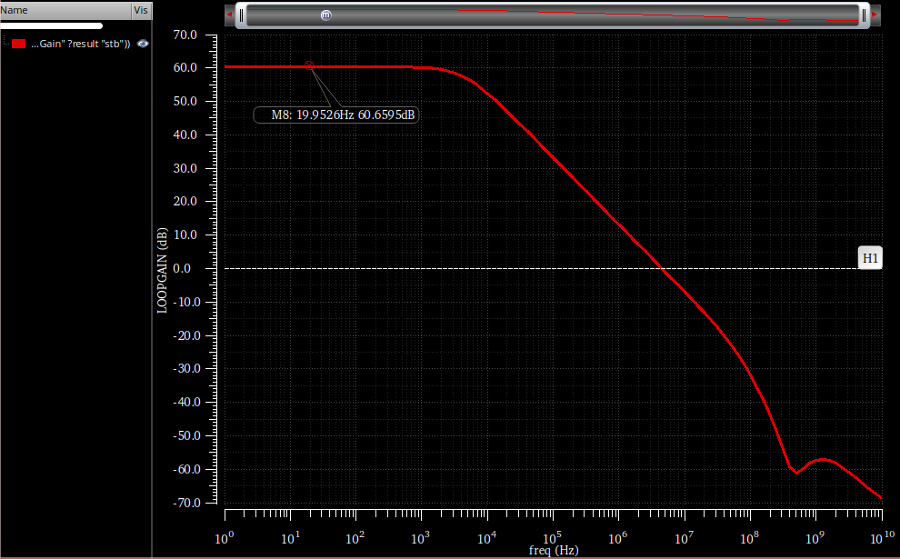
Figure 34: Common-Mode Loop Gain magnitude (dB)
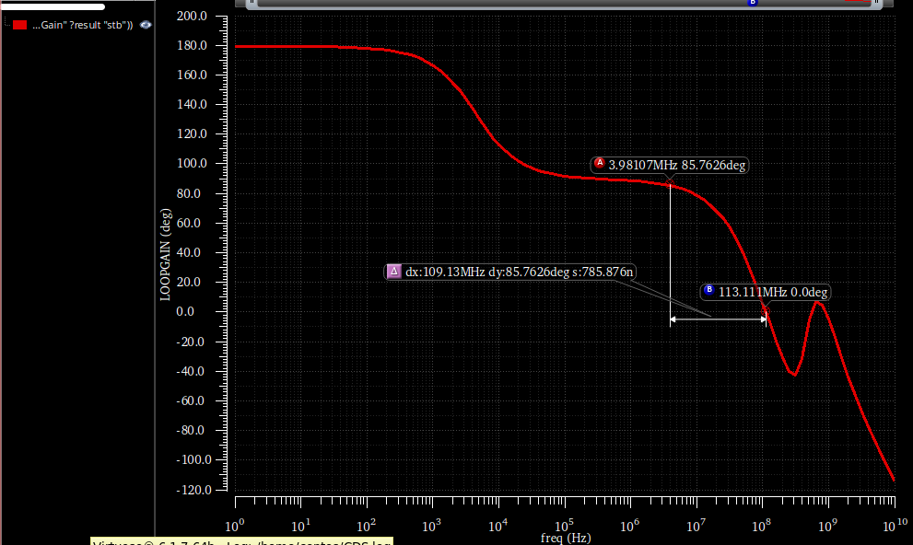
Figure 35:Common-Mode Loop Gain phase
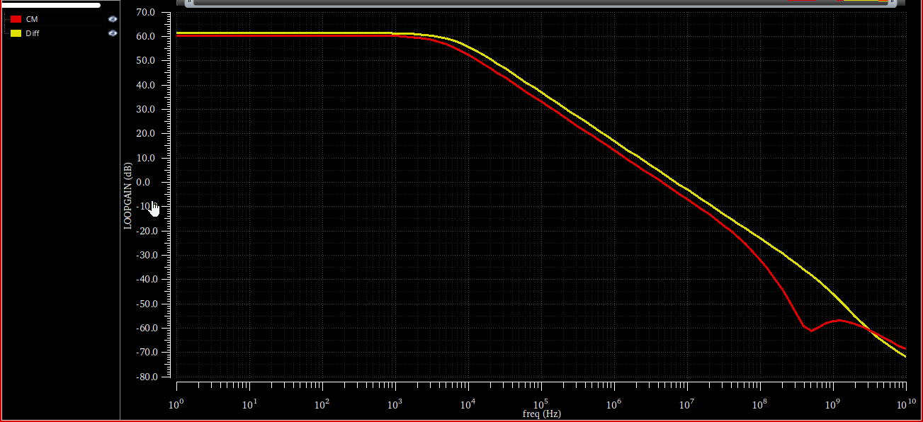
Figure 36: LG overlaid
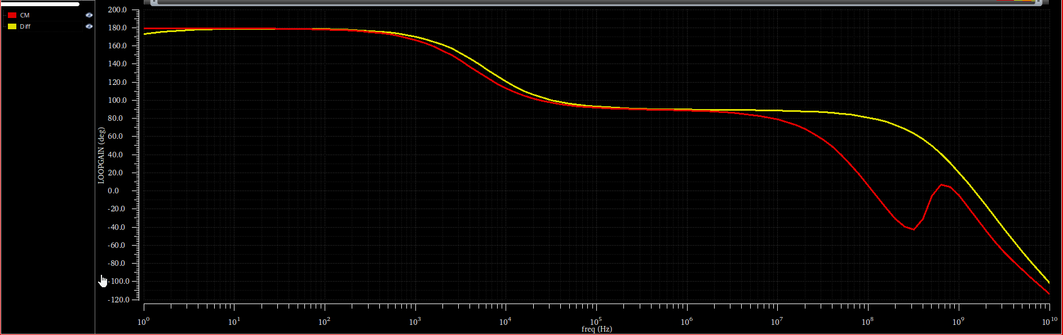
Figure 37: LG phase overlaid
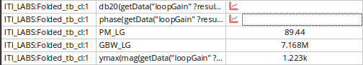
Figure 38: Differential Loop Gain

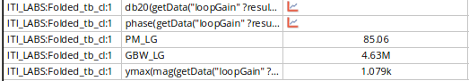
Figure 39: CM Loop Gain
Parameter | Differential Loop | Common-Mode Loop
DC Loop Gain (LG) | 61.65 dB (1.223k V/V) | 60.65 dB (1.079k V/V)
Loop Gain GBW | 7.168 MHz | 4.63 MHz
Phase Margin (PM) | 89.44° | 85.06°
Compare GBW and PM of diff and CM loops. Comment.
 | Diff | CM
GBW | 7.168 | 4.63
PM | 89 | 85

The differential loop has a higher Loop Gain GBW (7.168 MHz) compared to the CM loop (4.63 MHz). This is expected. The differential signal path is short and driven by the massive $g_{m}$ of the main input pair. The CM signal path travels through the CD and the error amplifier.
Compare DC LG and GBW of the diff loop with those obtained from open-loop simulation. Comment.
 | LG | OL
GBW | 7.168 | 50
DC LG | 61.65 dB (1.223k V/V) | 71dB

In the open-loop simulation (Part 4), the DC gain was 71.16 dB and the GBW was 50.31 MHz. In this STB simulation, the DC Loop Gain drops to 61.65 dB. This exact $≈9.5$ dB drop perfectly matches the feedback factor ($β$) introduced by the capacitive divider: $β=C_{f}/\left(C_{s}+C_{f}\right)=1\text{pF}/3\text{pF}=1/3$, and $20\log_{10}\left(1/3\right)=-9.54$ dB. The STB GBW (7.168 MHz) is the BWcl which is the $GBWloaded\frac{\left(= 23\right)}{Beta}=7.67MHz$.
- PART 6: Closed Loop Simulation (Transient):
  - Differential and CMFB loops stability:
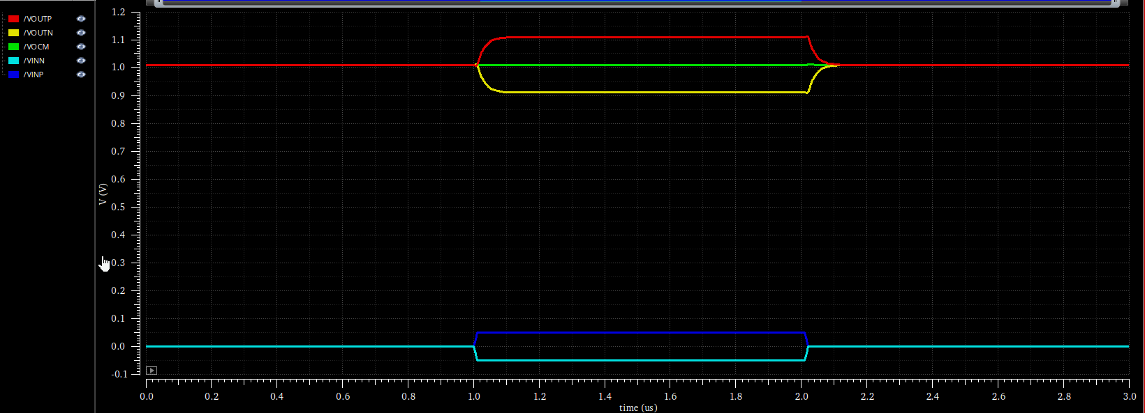
Figure 40: VINP, VINN, VOUTP, VOUTN, and VOCM overlaid
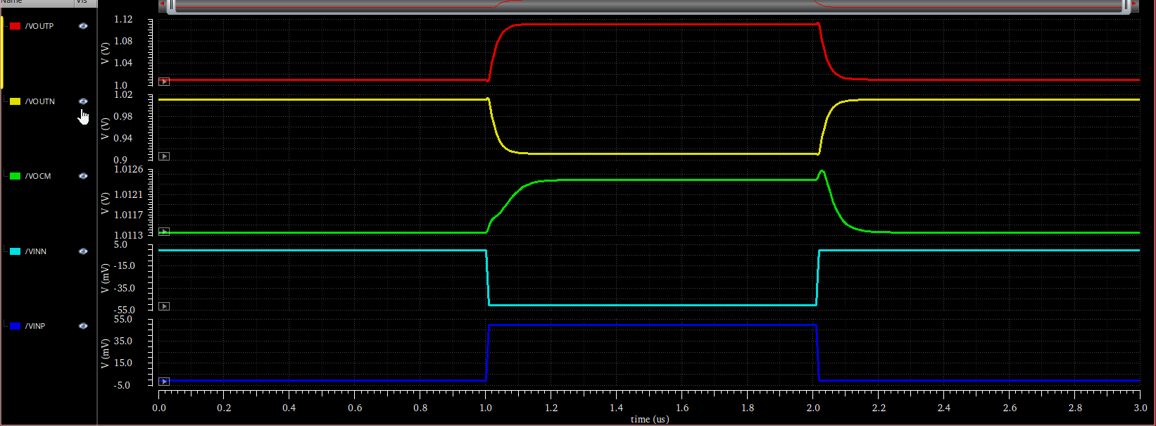
Figure 41: VINP, VINN, VOUTP, VOUTN, and VOCM
Do you notice any differential/CM ringing? Are both loops stable with adequate PM?
No ringing just a little overshoot in the VOCM as we have high PM.
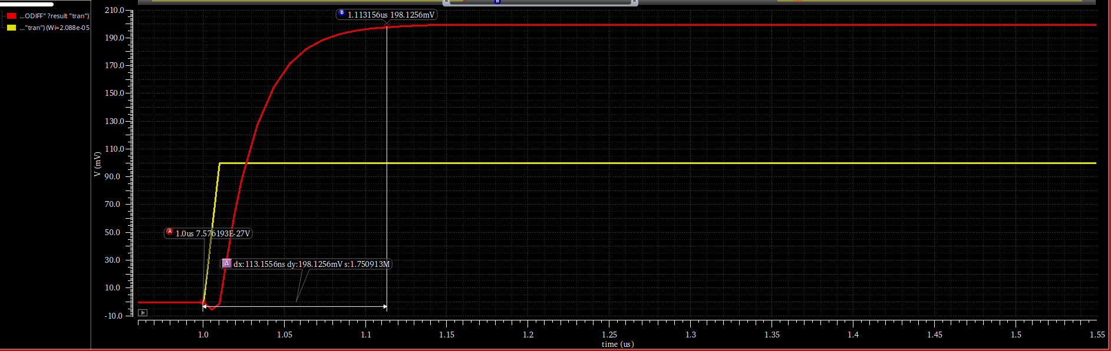
Figure 42: settling time before
To fix the settling time we should increase the GBW we can do that by increasing the width of the input pair to 30u instead of 21u and also increase the VCASCN to 1.3 instead of 1.2 and reduce VCASCP to 1 instead of 1.15 to increase the ro thus increasing Rout.
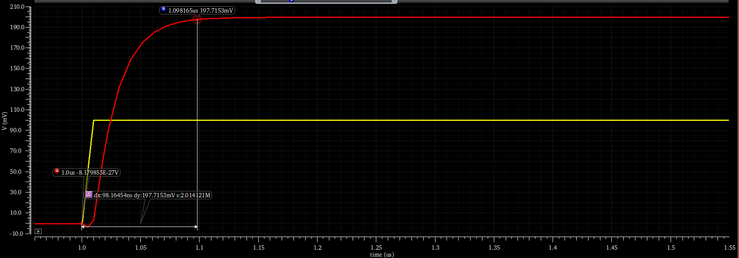
Figure 43: settling time after
Settling time = 98 ns which meets the specs.
  - Differential and CMFB loops stability (transient analysis):
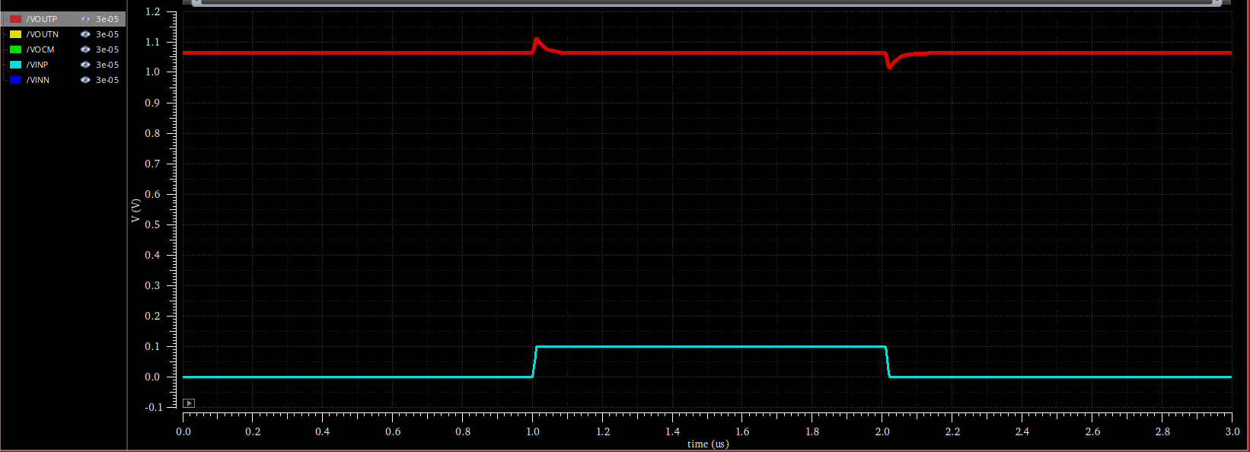
Figure 44: Transient response to a 100mV common-mode step pulse
No ringing in CM or DIFF there is a little overshoot due to the capacitors where in transitions which is high frequency the caps become short circuit this only in transition which is high freq.
  - Output swing:
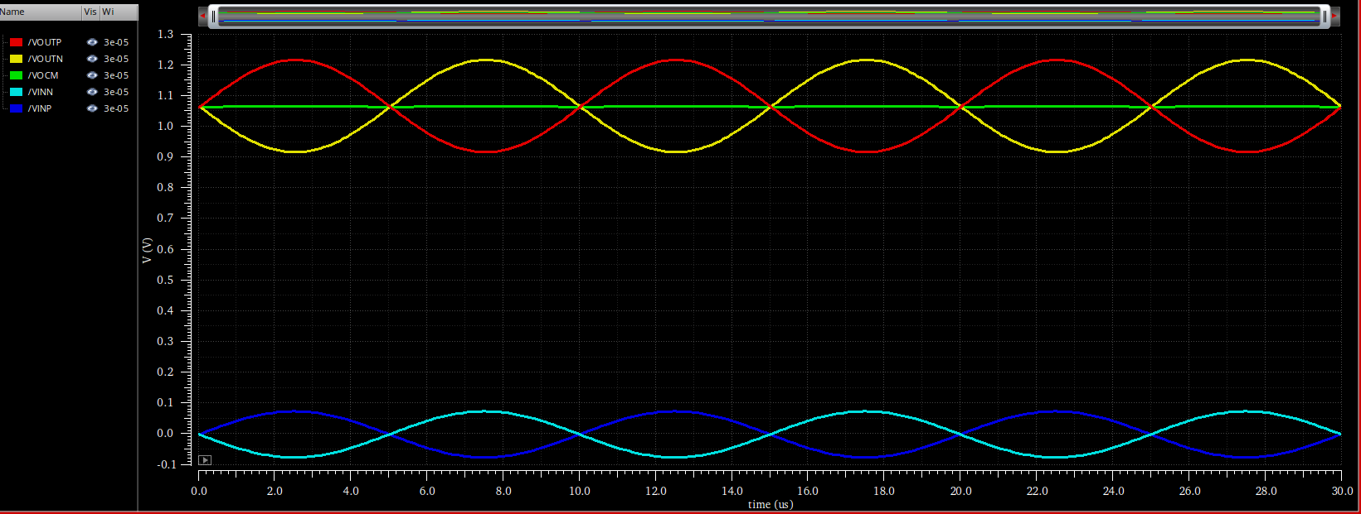
Figure 45: Transient output swing over three complete periods.
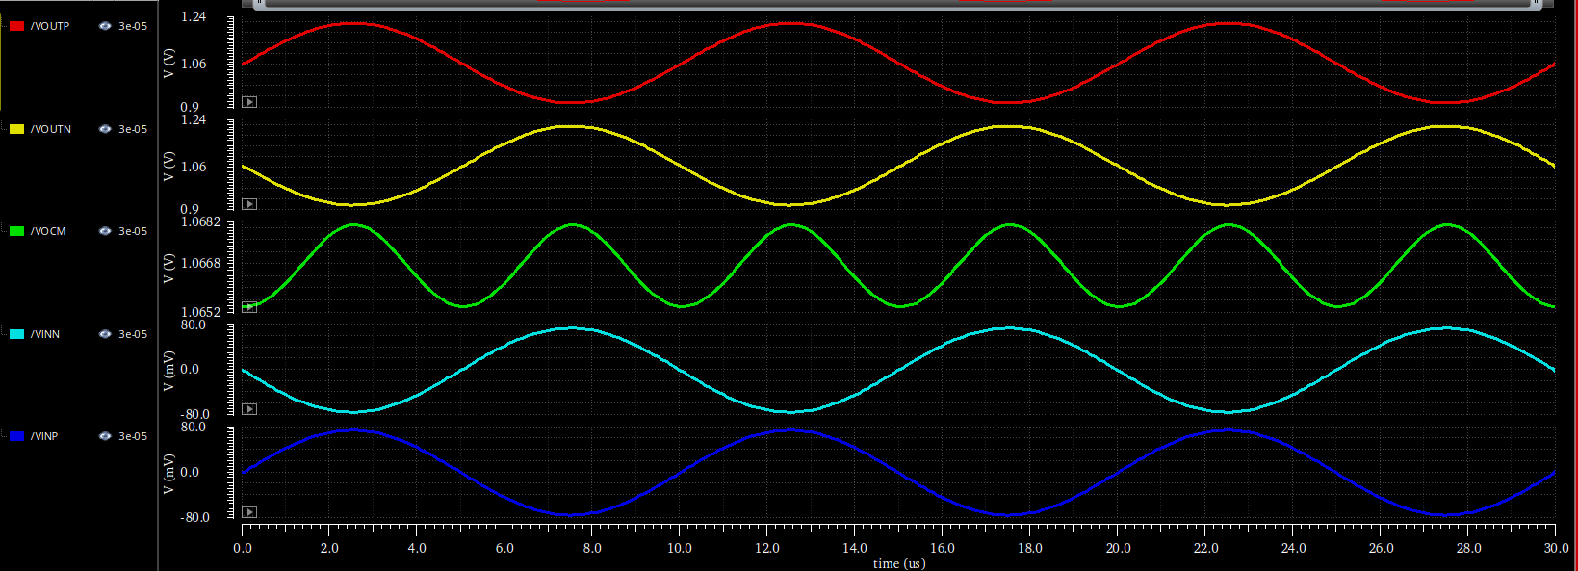
Figure 46: Zoomed-in view of the sinusoidal input and output waveforms.
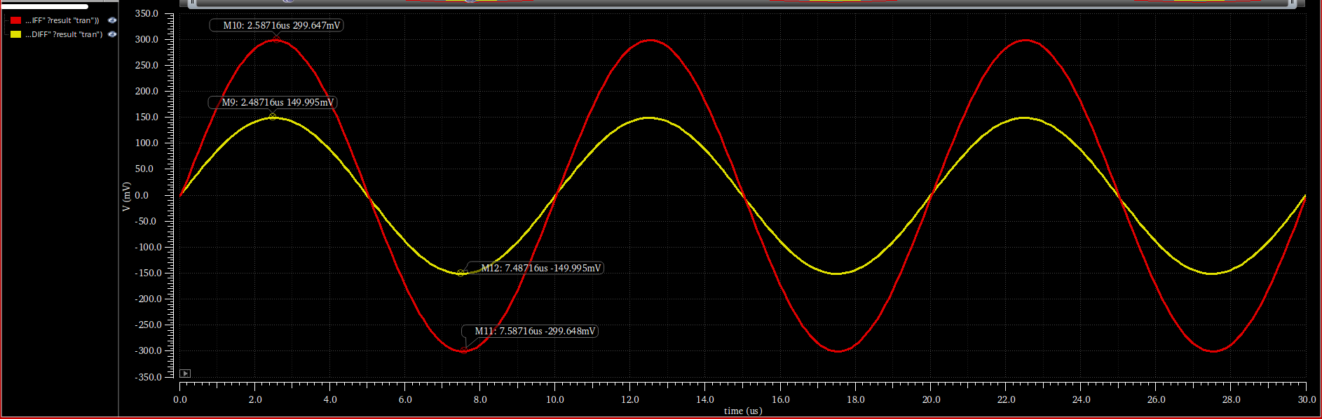
Figure 47: VIDIFF and VODIFF overlaid
As we see when the Vin amplitude = 150m the Vout is 300m that’s because the closed loop gain = 2
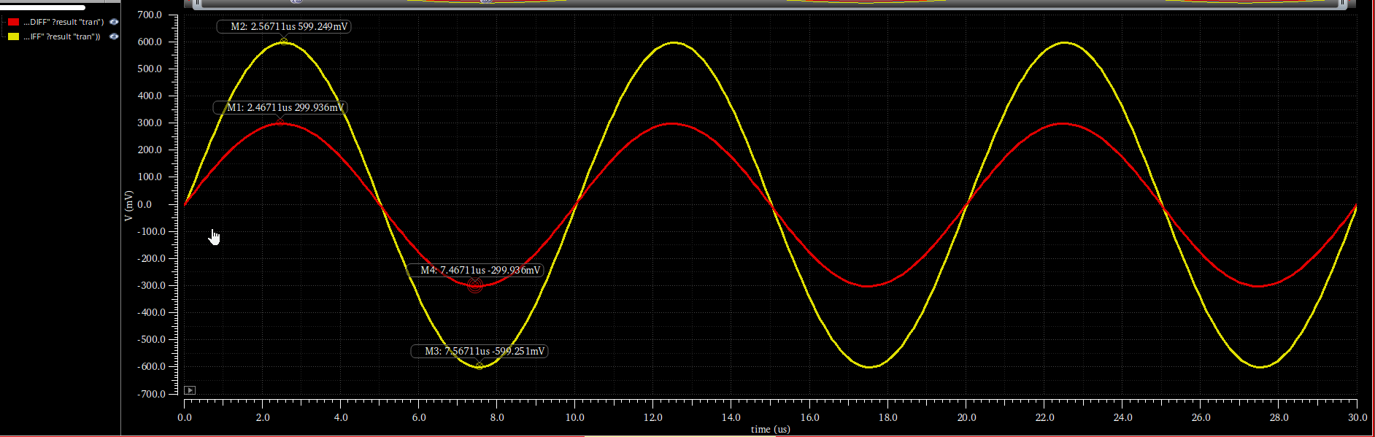
Figure 48: Vout peak to peak
As we see $Vin_pp=600m$
$$Vout_pp = 1.2V$$
$$So Av= Vout_pp/Vin_pp= 2$$

I did rough trans analysis by putting the amplitude of input = 1.1 to know what can my circuit do
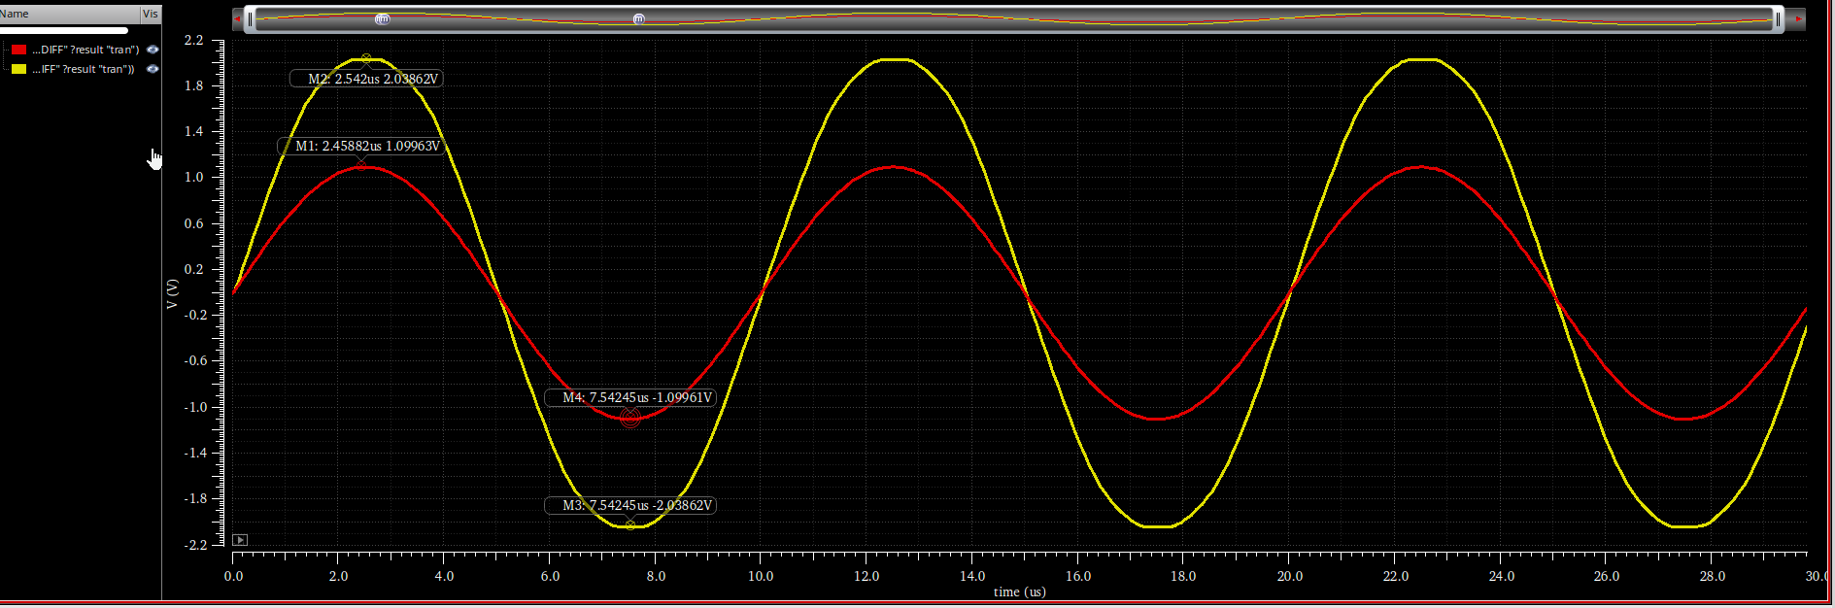
Figure 49: MAX peak to peak
As we see the circuit clipped at 2V which is 4V peak to peak.
    - CMIR Range:
I swept over Vicm and plotted GBW to know the CMIR
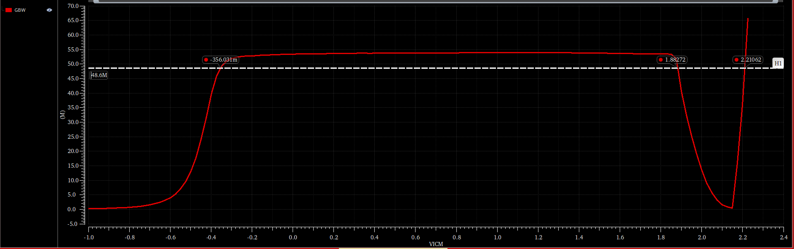
Figure 50: CMIR
Vin_low = -350m
Vin_high = 1.9
Which meets the specs !
- Bonus Part:
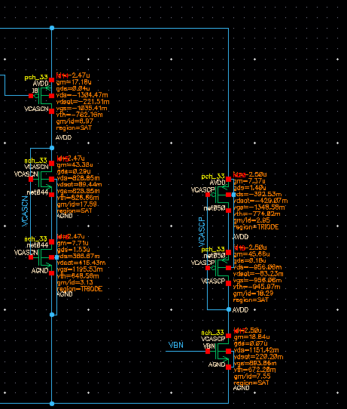
  - Bias Circuit:
We will use magic battery for VCASCN and VCASCP
In the left circuit (VCASCN) we will sweep over W or L to get Vgs= VCASCN =1.2 and the same for the right circuit we will sweep till we get VCASCP= 1.15
Also the diode connected devices is the same sizing the cascode devices we just sweep over the device we get VGS from.

I choose L and swept over W
NMOS: L= 10u
PMOS: L = 2u

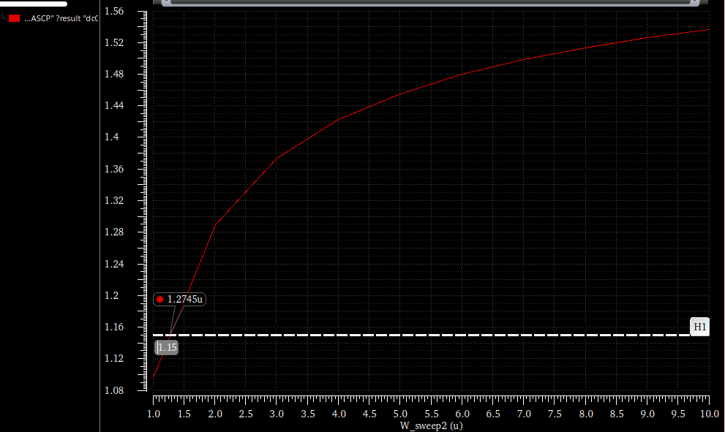
Figure 51: VCASCP
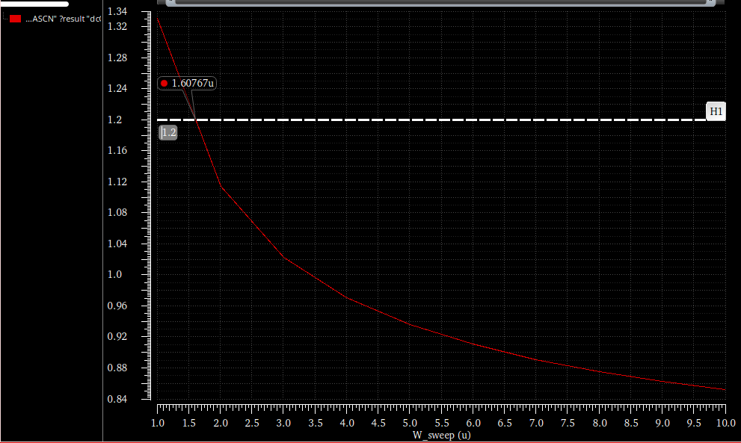
Figure 52: VCASCN

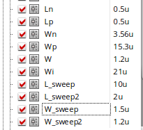
So this is the final sizing of the magic battery.

i designed the 2 magic batteries so that the total current of them equals 5u, as we see I=4.97u.
Figure 53: Magic battey OP

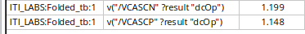
Here is the final bias voltages we got.
    - AC analysis :
I run Ac analysis for closed loop using the bias voltages we got
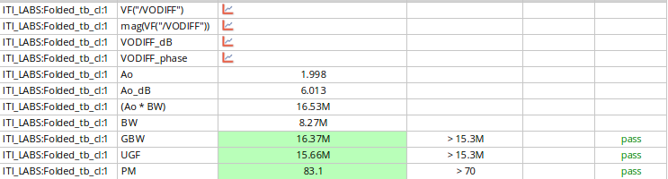
Which is the same results when we used a biasing voltage dc.

